**Traffic Product Test Cage**

**Hardware and Software Development Specification**

**Full Ball, Arrow, Pedestrian (Man/Hand/Countdown)**

**Authors:**

Gary A. Steinberg

Benoit Deridder

**Revision:** 1.0.0

**Revision Date**: 6/2/25

**Table of Contents**

1. **Purpose**
2. **Scope**
3. **Normative References**
4. **Informative References**
5. **Definitions**
6. **Test Cage (Tower) Hardware Architecture**

4.1 Overview

* 1. Hardware Details by Device

1. **Product Types Supported and Testing Requirements by Product Type**
   1. Full Ball and Arrow
   2. Pedestrian (Man/Hand/Countdown)
2. **MES Interface and Role in Test Sequencing**
   1. MES Server
   2. MES Message Passing/Commands
   3. Product Label Printing
   4. S/N Label Printing
   5. Carton Label Printing
3. **SQL Database and Interface for Test Data Storage**
   1. SQL Server
4. **Data Input (Test Code/Test Configuration) by Product Type**
   1. Full Ball and Arrow
   2. Pedestrian
5. **Data Output (Test Results) by Product Type**
   1. Full Ball and Arrow
   2. Pedestrian
6. **User Interface by Operating Mode**
   1. **Product Testing**
   2. **Calibration and Service**
7. **User Types and Permissions**
8. **Test Process Flow by Product Type**
   1. Takt Time Goal
   2. Measurement Sequence and Timing
9. **Cyber Security/Documentation Measures**
   1. OWASP
   2. Commenting Practice in Code
10. **Technical Support Features**
    1. Remote Access/Debugging
    2. Phone/Email Support
    3. Other?
11. **Project Acceptance criteria**
    1. Deliverables list
    2. PVP Completion
    3. Executable and Source Code Delivery
    4. Documentation Detail … support future developer understanding of Code funcation
    5. Team Signoff

**1. Purpose**

This document provides the detailed specifications for a production “test cage” capable of measuring the photometric and electrical performance properties of both AC and DC powered solid state (LED) traffic signaling products of several types. The test cage provides a 4 meter (160”) on-axis optical test distance as a folded optical system of 2 legs of 2 meters for factory height reasons. The system measures:

* on-axis correlated luminous intensity
* colorimetry (e.g., CCX, CCY, and Dominant Wavelength)
* full electrical parameters (i.e., test voltage, current, wattage, power factor, and total harmonic distortion)
* electrical performance at a series of defined test voltages (i.e., nominal, low, and high line conditions)
* electrical turnoff at a specified supply voltage value
* proper function of countdown features in pedestrian signal products.

The system is a US-based equivalent to multiple factory systems used in MX, VN, and other global production locations. The data collected is used as production audit information for QA purposes as well as maintaining product and factory certification status under NTRL audits per the relevant ITE (Institute of Transportation Engineers) standards controlling opto-electronic performance minimums of these product types. Products are 100% tested and records of unit test results are retained for a period of 7 yrs as required by the product certification requirements. The system responds to test request information provided by the Current MES (Manufacturing Execution System) and a database of “Test Codes” organized by product type in an SQL database and returns PASS/FAIL determinations on a unit basis with test data to be recorded in an second SQL database for short-term access and archived storage.

Testing, Maintenance, and Calibration Operations are achieved by authorized personnel thru appropriate Graphical User Interfaces (GUI’s) to simplify the user experience.

**2. Scope**

The scope of this document covers the critical information necessary to understand the physical structure of the Traffic Test Cage and the technical details necessary to ensure the required performance measurement resolution accuracy and to define the operational interfaces and functional behaviors of the controlling software, electrical interfaces, safety systems, and opto-mechanical details and alignment. In specific it addresses the following:

* Overall functional architecture in block diagram form
* Major components, specifications, and performance requirements
* Details of the measured performance parameters of the Devices Under Test (DUT) and the upper and lower limits of acceptable test results for each parameter and by DUT.
* Interface and command communication with the MES (Manufacturing Execution Systems) for batch, unit and label printing functions
* Interface and communication with the Structured Query Language (SQL) Database used to store the “Test Codes” from which the systems sets-up the test limits and test sequence
* Interface and communication with SQL Database used to store the “Test Results” for QA and archived NTRL retention purposes.
* Definitions of test sequence information by product type that clarify the process flow and sub-steps for properly collecting the desired test data inclusive of any necessary process dwells for thermal of electrical stability reasons.
* Opto-mechanical accuracy, alignment, and stability requirements for DUT holding jigs and DUT to optical system axes and the test operating environment.
* Summary of electrical power requirements for the testing apparatus
* Specific w/r to expected “safety’ subsystems and functions for test operators and maintenance personnel,
* Definitions of operator graphical user interfaces (GUI’s) layout and content as are expected to appear on the Host Computer monitor by operating mode (e.g., test, maintenance, and calibration).
* Calibration methods to achieve desired accuracy in spectral and far-field intensity as function of device type and emission color.
* Other?

The goal of the scope is to ensure the understanding of the system and to facilitate software development to implement the defined functionality.

**3. Normative References**

ITE (Institute of Traffic Engineers)

Vehicle Traffic Control Signal Heads - Light Emitting Diode (LED) Circular Signal Supplement, June 27, 2005

Pedestrian Traffic Control Signal Indicators - Light Emitting Diode (LED) Signal Modules, August 4, 2010

**4. Informative References**

None .. TBD

**5. Definitions**

**Unless otherwise defined … list default reference for definitions.**

**Full Ball**

**Arrow**

**Pedestrian**

**Dominant Wavelength**

**Test Code**

**6. Test Cage (Tower) Hardware Architecture**

A. Overview

Figure 1. Functional diagram of Traffic Test Cage illustrating basic optical system and major instrument elements.

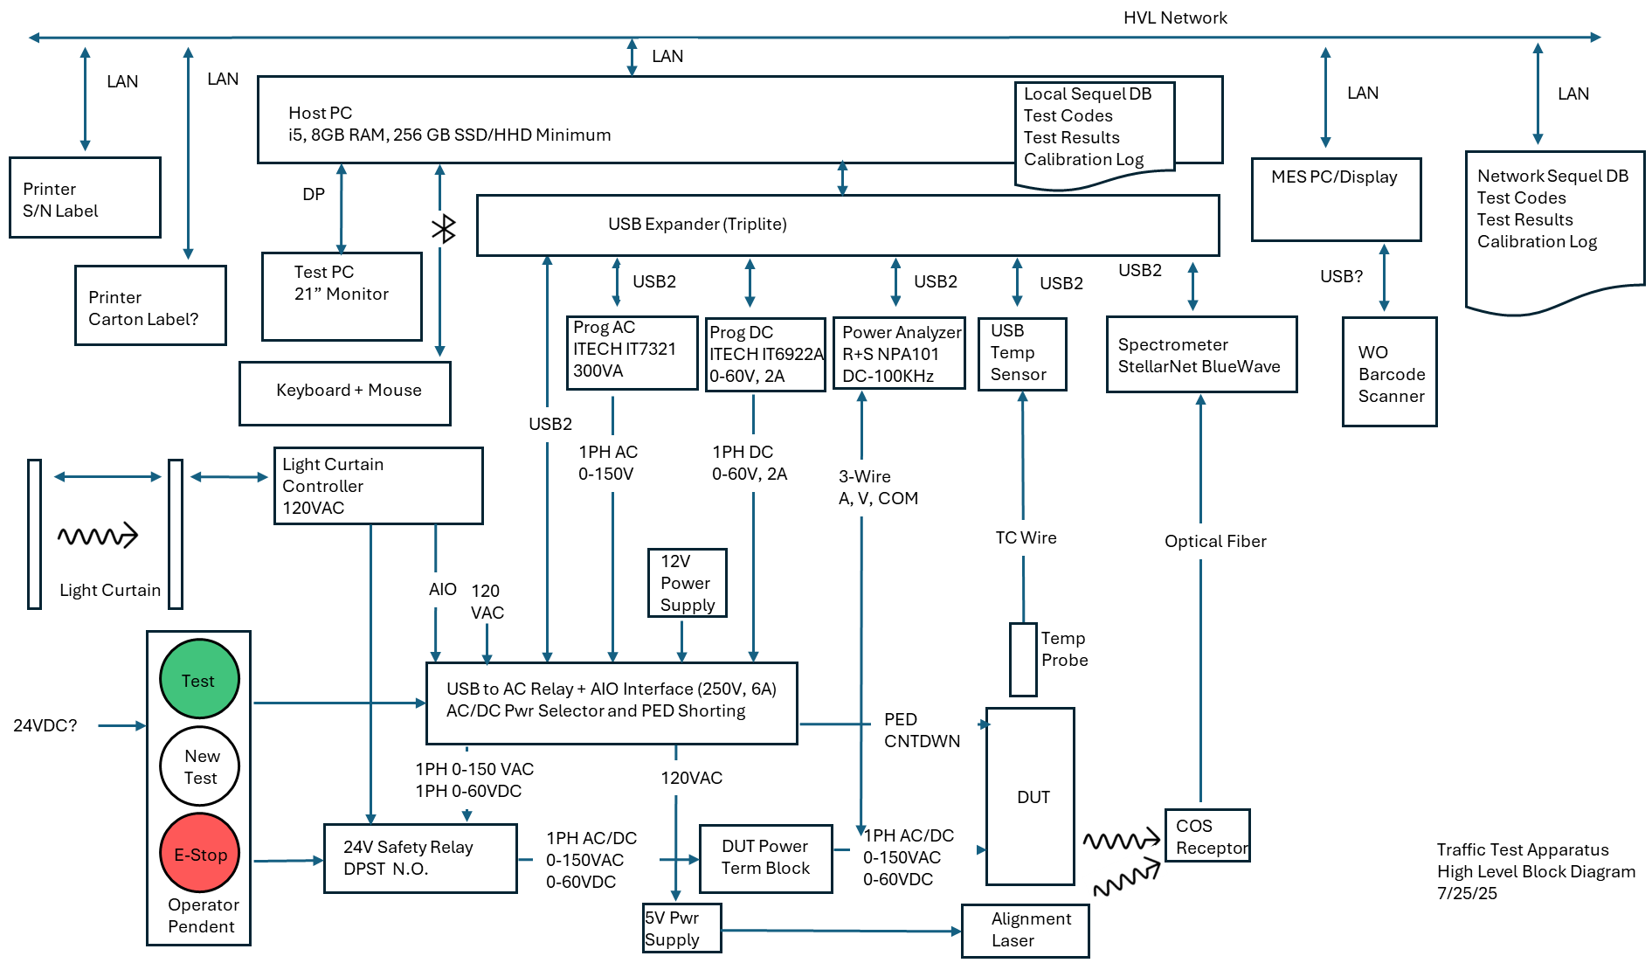

Figure 2. Functional diagram of Traffic Test Cage illustrating system elements and basic electrical functionality

B. Hardware Details by Device

|  |  |  |
| --- | --- | --- |
| **Functional Role** | **Suggested Device** | **Key Requirements** |
| Host PC | Dell Optiplex Small Form Factor | i5, 16GB RAM, 512 GB SSD, RS232, 4 Back Panel USB 2.0 or higher  Win 11 |
| Monitor | Dell or Equivalent | 24” FHD |
| Keyboard/Mouse | Dell, Logitech or Equivalent | Wired or Wireless |
| USB Expander | Triplite U360-007 or U360-007-AL 7 Port USB 3.0 with Fast Charging Support | 7 Port USB 2.0 or higher w/ 100 mA power |
| Spectrometer | StellarNet  BW-VIS2 (380-780 nm)  F600-VISNIR 600 um Core Armored Fiber Bundle  CR2 Miniature Cosine Receptor  Software Bundle | 380-780nm  1 nm resolution  2m fiber bundle  Cosine Receptor  USB Interface  SDK for colorimetry calcs |
| Power Analyzer | Rhode and Schwarz NPA101 | AC or DC measurement  0,01V Resolution  0.01A Resolution  0.01W Resolution  PF Measurement  THD Measurement  USB Interface |
| AC Power Supply | ITECH IT7321  0-150VAC  45-500Hz  300VA | 30-140V Output Min Range  50/60Hz output  30 VA minimum  USB Interface |
| DC Power Supply | ITECH IT6922A  DC Output  0-60VDC  100W | DC Output  Up to 60V  30W minimum  USB Interface |
| Light Curtain Bars | Omron STI MS4800 length as needed 14” (350 mm) recommended | Suggest 12” (300mm) units to minimize size close to Test Tower DUT opening |
| Light Curtain Control | Omron STI RM-2AC-IP-SB1 | 100-240VAC  24VDC and N.C/N.O. Relay Channels to Host PC I/O Port |
| Folding Mirror | Edmund Optics  250 x 250mm x 3mm  Enhanced Aluminum, 4-6λ Mirror  Stock #29-417 | Flatness  Front/Back Parallelism  Reflectivity Minimum |
| Tip Tilt Stage | Misumi  Item Number TD-104  125mm x 125mm 2 axis tilt stage  +/-2 degrees tilt range  Aluminum | +/- 2 degrees adjustment in 2 axes. |
| USB Relay Board | Relay Pros R85PL-USB  USB Relay Switch 8-Channel 5-Amp ProXR Lite w/ 12V Power Supply | 8 Channel, SPDT Relays  5A, 250V Relays  8 Channel Analog Input  Power Supply  USB Interface |
| Alignment Laser | Edmund Optics  #37-029: 1 mW Alignment Laser  5V, 1.2 A wall supply from Digikey | Red Visible Wavelength  Cylindrical Body  Longterm pointing stability better than 0.05 degrees  Power supply |
| Alignment Laser Mount | Newport? | Solution TBD pending assessment of laser beam angular alignment |
| Temperature Probe | Omnitechnik OT60-B | Thermocouple Type – K/J?  Temp accuracy +/-0.8 °C  USB Interface  Win 11 Compatible |
| MES Terminal | Elo ESY2213 or Equivalent | VESA Mount  Touch Screen  Barcode Scanner Input |
| Barcode Scanner | Motorola Symbol  Motorola D457  Zebra | Device as appropriate for scan symbology and MES terminal interface. |
| S/N Label Printer | TBD |  |
| Carton Label Printer | Zebra ZM400 or Equivalent |  |
| Operator Pendant | Current Made  Test – Momentary  New Test - Momentary  E-Stop – Push to Lock/Twist to Unlock | Test and New Test are momentary push buttons to provide logic state vis Real PCBA AIO port for starting DUT test or asking for new test code. E-Stop is combination of soft-stop and power output disable. |

**USB Relay Board Function Assignments by Relay Number**

|  |  |  |  |  |  |
| --- | --- | --- | --- | --- | --- |
| **Relay No.** | **Relay Type** | **Function** | **N.O. Contact** | **N.C. Contact** | **COM Contact** |
| 1 | SPDT | AC/DC Select - Pos | VDC+ | VAC+ | VSEL+ |
| 2 | SPDT | AC/DC Select - Neg | VDC- | VAC+ | VSEL- |
| 3 | SPDT | FB/Hand or Man – Pos |  |  | VSEL+ |
| 4 | SPDT | FB/Hand or Man - Neg |  |  | VSEL- |
| 5 | SPDT | Countdown Short | CTDWN+ | Open | CTDWN- |
| 6 | SPDT | Laser Pwr | LSR + | Open | 120V L1 |
| 7 | SPDT |  |  |  |  |
| 8 | SPDT |  |  |  |  |

**USB Relay Board Function Assignments by Analog Input Number**

|  |  |  |  |
| --- | --- | --- | --- |
| **Input No.** | **Function** | **Logic State** | **Action Req’ed** |
| 1 | Operator Pendant - Test | Hi ≥ 9V Low = ≤ 1V | Press and hold for 1 sec starts DUT test |
| 2 | Operator Pendant – New Test | Hi ≥ 9V, Low = ≤ 1V | Press and hold for 1 sec ends testing under current Test Code and asks for next Work Order/Test Code |
| 3 | Operator Pendant – E-Stop | Hi ≥ 9V, Low = ≤ 1V | Press to lock … creates open ckt and logic low |
| 4 | Light Curtain - Safe | Hi ≥ 9V, Low = ≤ 1V | Curtain intrusion creates open ckt in power safety relay coil and logic low |
| 5 |  |  |  |
| 6 |  |  |  |
| 7 |  |  |  |
| 8 |  |  |  |

**7. Product Types Supported and Testing Requirements by Product Type**

a. Full Ball and Arrow

See information in Annex A for basic Full Ball and Arrow product description

Testing Parameters for Full Ball and Arrow Products

|  |  |  |
| --- | --- | --- |
| **Test Condition** | **Measured Parameter** | **Requirement** |
| 120V | Test Voltage | Test Voltage +/-2% |
|  | Amps | ≤ UCL |
|  | Watts | LCL ≤ x ≤ UCL |
|  | Power Factor | LCL ≤ PF ≤ 1 |
|  | Total Harmonic Distortion | THD ≤ UCL |
|  | CCX /CCY (calc from SPD) | Within defined sub region of ITE color quadrangle for color |
|  | Dominant l (calc from SPD) | Nominal +/- XX nm |
|  | On-Axis Intensity (calc from SPD) | LCL ≤ x ≤ UCL |
| 80V | Test Voltage | Test Voltage +/-2% |
|  | Amps | ≤ UCL |
|  | Watts | LCL ≤ x ≤ UCL |
|  | Power Factor | LCL ≤ PF ≤ 1 |
|  | Total Harmonic Distortion | THD ≤ UCL |
|  | CCX/CCY (calc from SPD) | Within defined sub region of ITE color quadrangle for color |
|  | Dominant l (calc from SPD) | Nominal +/- XX nm |
|  | On-Axis Intensity (calc from SPD) | LCL ≤ x ≤ UCL |
| 135V | Test Voltage | Test Voltage +/-2% |
|  | Amps | ≤ UCL |
|  | Watts | LCL ≤ x ≤ UCL |
|  | Power Factor | LCL ≤ PF ≤ 1 |
|  | Total Harmonic Distortion | THD ≤ UCL |
|  | CCX /CCY (calc from SPD) | Within defined sub region of ITE color quadrangle for color |
|  | Dominant l (calc from SPD) | Nominal +/- XX nm |
|  | On-Axis Intensity (calc from SPD) | LCL ≤ x ≤ UCL |
| 35V | Test Voltage | Test Voltage +/-2% |
|  | Amps | ≤ UCL |
|  | On-Axis Intensity (calc from SPD) | ≤ UCL |

Test Sequence for Full Ball and Arrow Products

Step 1 Unit Test Requested? No? Step 1 Yes? Continue

Step 2 Apply supply voltage

Step 3 If first voltage Dwell 4 sec, else continue

Step 4 Measure Electrical Parameters (V, A, W, PF, THD)

Step 5 Pass/Fail? Yes … go to Step 9, No … continue

Step 6 Measure Optical Parameters

Step 7 Last Voltage? No .. go to Step 1 … Yes Apply Turn off voltage

Step 8 Measure Electrical Parameters

Step 9 Log Pass/Fail

Step 10 Return to Step 1

b. Pedestrian (Man/Hand/Countdown)

See information in Annex C for Pedestrian (Man/Hand/Countdown)

Testing Parameters for Pedestrian Products.

|  |  |  |
| --- | --- | --- |
| **Test Condition** | **Measured Parameter** | **Requirement** |
| 120V Hand | Test Voltage | Test Voltage +/-2% |
|  | Amps | ≤ UCL |
|  | Watts | LCL ≤ x ≤ UCL |
|  | Power Factor | LCL ≤ PF ≤ 1 |
|  | Total Harmonic Distortion | THD ≤ UCL |
|  | CCX and CCY (from SPD) | Within defined sub region of ITE color quadrangle for color |
|  | Dominant λ(from SPD) | Nominal +/- XX nm |
|  | On-Axis Intensity | LCL ≤ x ≤ UCL |
| 35V Hand | Test Voltage | Test Voltage +/-2% |
|  | Amps | ≤ UCL |
|  | On-Axis Intensity (calc from SPD) | ≤ UCL |
| 120V Man | Test Voltage | Test Voltage +/-2% |
|  | Amps | ≤ UCL |
|  | Watts | LCL ≤ x ≤ UCL |
|  | Power Factor | LCL ≤ PF ≤ 1 |
|  | Total Harmonic Distortion | THD ≤ UCL |
|  | CCX and CCY (from SPD) | Within defined sub region of ITE color quadrangle for color |
|  | Dominant λ (from SPD) | Nominal +/- XX nm |
|  | On-Axis Intensity | LCL ≤ x ≤ UCL |
| 35V Man | Test Voltage | Test Voltage +/-2% |
|  | Amps | ≤ UCL |
|  | On-Axis Intensity (calc from SPD) | ≤ UCL |
| 120V Cntdwn | Test Voltage | Test Voltage +/-2% |
|  | Amps minus 120V Hand Value | ≤ UCL |
|  | Watts minus 120V Hand Value | LCL ≤ x ≤ UCL |
|  | Power Factor | LCL ≤ PF ≤ 1 |
|  | Total Harmonic Distortion | THD ≤ UCL |
|  | CCX and CCY (from SPD) | Within defined sub region of ITE color quadrangle for color |
|  | Dominant λ (from SPD) | Nominal +/- XX nm |
|  | On-Axis Intensity (calc from SPD) minus 120V Hand Value | LCL ≤ x ≤ UCL |

Test Sequence for Pedestrian Products

**8. MES Interface and Role in Test Sequencing**

a. MES Server

b. MES Message Passing/Commands

c. Product Label Printing

d. S/N Label Printing

e. Carton Label Printing

**9. SQL Database and Interface for Test Data Storage**

The system operates based on retrieval of “Test Code” data and storage of “Test Results” data in network and locally hosted SQL database instances on the Host PC and an SQL server accessible via the company LAN. In operation the Network SQL instances serve as the “Master” data copies and the Host PC instances serve as short-term backup copies in the event that the Network copy becomes inaccessible during test activity. At start up, the Tester executable queries the Network Test Code instance to update the Host PC Test Code data to reflect the most recent list of possible test codes and to revise any test parameters that have been changed. Test Results are written to the local Host PC Test Results instance and copied to the Network instance as long as the Network instance is operable. If the Network instance is not accessible, the Test Results are accumulated in the Host PC instance until Network access is re-establish and then the Host PC information is written to the Network. The Network Test Results copies also serve as backed-up archival data for the test activity to meet the 7 yr data preservation requirements for production testing data. This Network Test Results data could also be ‘mined’ for QA and statistical analysis purposes if needed.

**10. Data Input (Test Code/Test Configuration) by Product Type**

The following tables are a list of Test Code information by product type organized by column-order of occurrence in the SQL database fields. The required units, reporting precision, and brief statement of function are provided for reference.

1. **Full Ball and Arrow**

|  |  |  |  |  |
| --- | --- | --- | --- | --- |
| **Field No.** | **Parameter Name** | **Units** | **Precision** | **Function** |
|  | UID | Int | N/A | Auto Generated SQL record index number |
|  | TEST_CODE | Text |  | Test Code and Dash Number (e.g., T6435-03) |
|  | DESCRIPTION | Text | N/A | Typically the product code and a series of descriptive parameters (e.g., DR6, VLA2 Full Ball, 12”, Green, 120V, 10W) |
|  | SPARE1 | N/A | N/A | Are these needed? |
|  | SPARE2 | N/A | N/A | Are these needed? |
|  | CAT NUMBER | Text | N/A | Product specific cat logic for the SKU? |
|  | NOM_VOLTS | V | XXX.X | Supply voltage nominal line |
|  | NOM_VOLTS_LSL | V | XXX.X | Supply voltage nominal line upper spec limit |
|  | NOM_VOLTS_USL | V | XXX.X | Supply voltage nominal line lower spec limit |
|  | NOM_MAMPS | mA | XXX.X | Supply amperage nominal line |
|  | NOM_MAMPS_LSL | mA | XXX.X | Supply amperage nominal line upper spec limit |
|  | NOM_MAMPS_USL | mA | XXX.X | Supply amperage nominal line lower spec limit |
|  | NOM_WATTS | W | XX.XX | Supply wattage nominal line |
|  | NOM_WATTS_LSL | W | XX.XX | Supply wattage nominal line upper spec limit |
|  | NOM_WATTS_USL | W | XX.XX | Supply wattage nominal line lower spec limit |
|  | LO_VOLTS | V | XXX.X | Supply voltage low line |
|  | LO_VOLTS_LSL | V | XXX.X | Supply voltage low line upper spec limit |
|  | LO_VOLTS_USL | V | XXX.X | Supply voltage low line lower spec limit |
|  | LO_MAMPS | mA | XXX.X | Supply amperage low line |
|  | LO_MAMPS_LSL | mA | XXX.X | Supply amperage low line upper spec limit |
|  | LO_MAMPS_USL | mA | XXX.X | Supply amperage low line lower spec limit |
|  | LO_WATTS | W | XX.XX | Supply wattage low line |
|  | LO_WATTS_LSL | W | XX.XX | Supply wattage low line upper spec limit |
|  | LO_WATTS_USL | W | XX.XX | Supply wattage low line lower spec limit |
|  | HI_VOLTS | V | XXX.X | Supply voltage high line |
|  | HI_VOLTS_LSL | V | XXX.X | Supply voltage high line upper spec limit |
|  | HI_VOLTS_USL | V | XXX.X | Supply voltage high line lower spec limit |
|  | HI_MAMPS | mA | XXX.X | Supply amperage high line |
|  | HI_MAMPS_LSL | mA | XXX.X | Supply amperage high line upper spec limit |
|  | HI_MAMPS_USL | mA | XXX.X | Supply amperage high line lower spec limit |
|  | HI_WATTS | W | XX.XX | Supply wattage high line |
|  | HI_WATTS_LSL | W | XX.XX | Supply wattage high line upper spec limit |
|  | HI_WATTS_USL | W | XX.XX | Supply wattage high line lower spec limit |
|  | OFF_VOLTS | V | XXX.X | Supply voltage at turn off |
|  | OFF_VOLTS_LSL | V | XXX.X | Supply voltage at turn off upper spec limit |
|  | OFF_VOLTS_USL | V | XXX.X | Supply voltage at turn off lower spec limit |
|  | OFF_MAMPS | mA | XXX.X | Supply amperage at turn off Needed? |
|  | OFF_MAMPS_LSL | mA | XXX.X | Supply amperage at turn off upper spec limit. Needed? |
|  | OFF_MAMPS_USL | mA | XXX.X | Supply amperage at turn off lower spec limit |
|  | OFF_WATTS | W | XX.XX | Supply wattage at turn off Needed? |
|  | OFF_WATTS_LSL | W | XX.XX | Supply wattage at turn off upper spec limit. Needed? |
|  | OFF_WATTS_USL | W | XX.XX | Supply wattage at turn off lower spec limit |
|  | PF_LSL | N/A | 0.XXX | Power Factor lower spec limit |
|  | THD_USL | PCT | XX.X | Total Harmonic Distortion upper spec limit |
|  | CCX1 | N/A | 0.XXXX | Upper right color quadrangle point X value |
|  | CCX2 | N/A | 0.XXXX | Lower right color quadrangle point X value |
|  | CCX3 | N/A | 0.XXXX | Lower left color quadrangle point X value |
|  | CCX4 | N/A | 0.XXXX | Upper left color quadrangle point X value |
|  | CCY1 | N/A | 0.XXXX | Upper right color quadrangle point Y value |
|  | CCY2 | N/A | 0.XXXX | Lower right color quadrangle point Y value |
|  | CCY3 | N/A | 0.XXXX | Lower left color quadrangle point Y value |
|  | CCY4 | N/A | 0.XXXX | Upper left color quadrangle point Y value |
|  | DOM_LAMBDA | NM | XXX.X | Dominant wavelength nominal |
|  | DOM_LAMBDA_LSL | NM | XXX.X | Dominant wavelength lower spec limit |
|  | DOM_LAMBDA_USL | NM | XXX.X | Dominant wavelength upper spec limit |
|  | INTENSITY | Cd | XXX.X | On-axis intensity nominal |
|  | INTENSITY_LSL | Cd | XXX.X | On-axis intensity lower spec limit |
|  | INTENSITY-USL | Cd | XXX.X | On-axis intensity upper spec limit |
|  |  |  |  |  |
|  |  |  |  |  |

1. **Pedestrian**

|  |  |  |  |  |
| --- | --- | --- | --- | --- |
| **Field No.** | **Parameter Name** | Units | Precision | Function |
|  | UID | Int | N/A | Auto Generated SQL record index number |
|  | TEST_CODE | Text | N/A | Test Code and Dash Number (e.g., T6435-03) |
|  | PROGRAM | Text | N/A | Purpose? |
|  | DESCRIPTION | Text | N/A | Typically the product code and a series of descriptive parameters (e.g., DR6, VLA2 Full Ball, 12”, Green, 120V, 10W) |
|  | SPARE1 | N/A | N/A | Are these needed? |
|  | SPARE2 | N/A | N/A | Are these needed? |
|  | CAT NUMBER | Text | N/A | Product specific cat logic for the SKU? |
|  | HND_NOM_VOLTS | V | XXX.X | Hand supply voltage nominal line |
|  | HND_ NOM_VOLTS_LSL | V | XXX.X | Hand supply voltage nominal line lower spec limit |
|  | HND_NOM_VOLTS_USL | V | XXX.X | Hand supply voltage nominal line upper spec limit |
|  | HND_NOM_MAMPS | mA | XXX.X | Hand supply amperage nominal line |
|  | HND_NOM_MAMPS_LSL | mA | XXX.X | Hand supply amperage nominal line lower spec limit |
|  | HND_NOM_MAMPS_USL | mA | XXX.X | Hand supply amperage nominal line upper spec limit |
|  | HND_NOM_WATTS | W | XX.XX | Hand supply wattage nominal line |
|  | HND_NOM_WATTS_LSL | W | XX.XX | Hand supply wattage nominal line lower spec limit |
|  | HND_NOM_WATTS_USL | W | XX.XX | Hand supply wattage nominal line upperr spec limit |
|  | HND_PF_LSL | N/A | 0.XXX | Hand Power Factor lower spec limit |
|  | HND_THD_USL | PCT | XX.X | Hand Total Harmonic Distortion upper spec limit |
|  | HND_CCX1 | N/A | 0.XXXX | Hand upper right color quadrangle point X value |
|  | HND_CCX2 | N/A | 0.XXXX | Hand lower right color quadrangle point X value |
|  | HND_CCX3 | N/A | 0.XXXX | Hand lower left color quadrangle point X value |
|  | HND_CCX4 | N/A | 0.XXXX | Hand upper left color quadrangle point X value |
|  | HND_CCY1 | N/A | 0.XXXX | Hand upper right color quadrangle point Y value |
|  | HND_CCY2 | N/A | 0.XXXX | Hand lower right color quadrangle point Y value |
|  | HND_CCY3 | N/A | 0.XXXX | Hand lower left color quadrangle point Y value |
|  | HND_CCY4 | N/A | 0.XXXX | Hand upper left color quadrangle point Y value |
|  | HND_DOM_LAMBDA | NM | XXX.X | Hand dominant wavelength nominal |
|  | HND_DOM_LAMBDA_LSL | NM | XXX.X | Hand dominant wavelength lower spec limit |
|  | HND_DOM_LAMBDA_USL | NM | XXX.X | Hand dominant wavelength upper spec limit |
|  | HND_INTENSITY | Cd | XXX.X | Hand on-axis intensity nominal |
|  | HND_INTENSITY_LSL | Cd | XXX.X | Hand on-axis intensity lower spec limit |
|  | HND_INTENSITY_USL | Cd | XXX.X | Hand on-axis intensity upper spec limit |
|  | HND_OFF_VOLTS | V | XXX.X | Hand nominal turn off supply voltage |
|  | HND_OFF_VOLTS_LSL | V | XXX.X | Hand turn off supply voltage lower spec limit |
|  | HND_OFF_VOLTS_USL | V | XXX.X | Hand turn off supply voltage upper spec limit |
|  | HND_OFF_MAMPS_USL | mA | XXX.X | Hand amperage upper spec limit at turn off supply voltage |
|  | HND_OFF_WATTS_USL | W | XX.XX | Hand wattage upper spec limit at turn off supply voltage |
|  | HND_OFF_INTENSITY_USL | Cd | XXX.X | Hand intensity upper spec limit at turn off supply voltage |
|  | MAN_NOM_VOLTS | V | XXX.X | Man supply voltage nominal line |
|  | MAN_NOM_VOLTS | V | XXX.X | Man supply voltage nominal line |
|  | MAN_ NOM_VOLTS_LSL | V | XXX.X | Man supply voltage nominal line upper spec limit |
|  | MAN_NOM_VOLTS_USL | V | XXX.X | Man supply voltage nominal line lower spec limit |
|  | MAN_NOM_MAMPS | mA | XXX.X | Man supply amperage nominal line |
|  | MAN_NOM_MAMPS_LSL | mA | XXX.X | Man supply amperage nominal line upper spec limit |
|  | MAN_NOM_MAMPS_USL | mA | XXX.X | Man supply amperage nominal line lower spec limit |
|  | MAN_NOM_WATTS | W | XX.XX | Man supply wattage nominal line |
|  | MAN_NOM_WATTS_LSL | W | XX.XX | Man supply wattage nominal line upper spec limit |
|  | MAN_NOM_WATTS_USL | W | XX.XX | Man supply wattage nominal line lower spec limit |
|  | MAN_PF_LSL | N/A | 0.XXX | Man Power Factor lower spec limit |
|  | MAN_THD_USL | PCT | XX.X | Man Total Harmonic Distortion upper spec limit |
|  | MAN_CCX1 | N/A | 0.XXXX | Man upper right color quadrangle point X value |
|  | MAN_CCX2 | N/A | 0.XXXX | Man lower right color quadrangle point X value |
|  | MAN_CCX3 | N/A | 0.XXXX | Man lower left color quadrangle point X value |
|  | MAN_CCX4 | N/A | 0.XXXX | Man upper left color quadrangle point X value |
|  | MAN_CCY1 | N/A | 0.XXXX | Man upper right color quadrangle point Y value |
|  | MAN_CCY2 | N/A | 0.XXXX | Man lower right color quadrangle point Y value |
|  | MAN_CCY3 | N/A | 0.XXXX | Man lower left color quadrangle point Y value |
|  | MAN_CCY4 | N/A | 0.XXXX | Man upper left color quadrangle point Y value |
|  | MAN_CCT | NM | XXX.X | Man CCT nominal |
|  | MAN_CCT_LSL | NM | XXX.X | Man CCT lower spec limit |
|  | MAN_CCT_USL | NM | XXX.X | Man CCT upper spec limit |
|  | MAN_INTENSITY | Cd | XXX.X | Man on-axis intensity nominal |
|  | MAN_INTENSITY_LSL | Cd | XXX.X | Man on-axis intensity lower spec limit |
|  | MAN_INTENSITY_USL | Cd | XXX.X | Man on-axis intensity upper spec limit |
|  | MAN_OFF_VOLTS | V | XXX.X | Man nominal turn off supply voltage |
|  | MAN_OFF_VOLTS_LSL | V | XXX.X | Man turn off supply voltage lower spec limit |
|  | MAN_OFF_VOLTS_USL | V | XXX.X | Man turn off supply voltage upper spec limit |
|  | MAN_OFF_MAMPS_USL | mA | XXX.X | Man amperage upper spec limit at turn off supply voltage |
|  | MAN_OFF_WATTS_USL | W | XX.XX | Man wattage upper spec limit at turn off supply voltage |
|  |  |  |  |  |
|  |  |  |  |  |
|  | HDCD_NOM_VOLTS | V | XXX.X | Hand+CD supply voltage nominal line |
|  | HDCD_ NOM_VOLTS_LSL | V | XXX.X | Hand+CD supply voltage nominal line upper spec limit |
|  | HDCD_NOM_VOLTS_USL | V | XXX.X | Hand+CD supply voltage nominal line lower spec limit |
|  | HDCD_NOM_MAMPS | mA | XXX.X | Hand+CD supply amperage nominal line |
|  | HDCD_NOM_MAMPS_LSL | mA | XXX.X | Hand+CD supply amperage nominal line upper spec limit |
|  | HDCD_NOM_MAMPS_USL | mA | XXX.X | Hand+CD supply amperage nominal line lower spec limit |
|  | HDCD_NOM_WATTS | W | XX.XX | Hand+CD supply wattage nominal line |
|  | HDCD_NOM_WATTS_LSL | W | XX.XX | Hand+CD supply wattage nominal line upper spec limit |
|  | HDCD_NOM_WATTS_USL | W | XX.XX | Hand+CD supply wattage nominal line lower spec limit |
|  | HDCD_PF_LSL | N/A | 0.XXX | Hand+CD Power Factor lower spec limit |
|  | HDCD_THD_USL | PCT | XX.X | Hand+CD Total Harmonic Distortion upper spec limit |
|  | HDCD_CCX1 | N/A | 0.XXXX | Hand+CD upper right color quadrangle point X value |
|  | HDCD_CCX2 | N/A | 0.XXXX | Hand+CD lower right color quadrangle point X value |
|  | HDCD_CCX3 | N/A | 0.XXXX | Hand+CD lower left color quadrangle point X value |
|  | HDCD_CCX4 | N/A | 0.XXXX | Hand+CD upper left color quadrangle point X value |
|  | HDCD_CCY1 | N/A | 0.XXXX | Hand+CD upper right color quadrangle point Y value |
|  | HDCD_CCY2 | N/A | 0.XXXX | Hand+CD lower right color quadrangle point Y value |
|  | HDCD_CCY3 | N/A | 0.XXXX | Hand+CD lower left color quadrangle point Y value |
|  | HDCD_CCY4 | N/A | 0.XXXX | Hand+CD upper left color quadrangle point Y value |
|  | HDCD_DOM_LAMBDA | NM | XXX.X | Hand+CD dominant wavelength nominal |
|  | HDCD_DOM_LAMBDA_LSL | NM | XXX.X | Hand+CD dominant wavelength lower spec limit |
|  | HDCD_DOM_LAMBDA_USL | NM | XXX.X | Hand+CD dominant wavelength upper spec limit |
|  | HDCD_INTENSITY | Cd | XXX.X | Hand+CD on-axis intensity nominal |
|  | HDCD_INTENSITY_LSL | Cd | XXX.X | Hand+CD on-axis intensity lower spec limit |
|  | HDCD_INTENSITY_USL | Cd | XXX.X | Hand+CD on-axis intensity upper spec limit |
|  |  |  |  |  |
|  |  |  |  |  |
|  | DELTA_DOM_LAMBA_USL | NM | XXX.X | Check on color consistency Hand to CD |
|  | CD_INTENSITY | Cd | XXX.X | Calc’ed CD on-axis intensity nominal: difference of HDCD-HND Intensity |
|  | CD_INTENSITY_LSL | Cd | XXX.X | Calc’ed CD on-axis intensity lower spec limit |
|  | CD_INTENSITY_USL | Cd | XXX.X | Calc’ed CD on-axis intensity upper spec limit |

**11. Data Output (Test Results) by Product Type**

The following tables are a list of Test Results information by product type organized by order of occurrence in the SQL database fields the required reporting precision and brief statement of function.

**a. Full Ball and Arrow**

|  |  |  |  |  |
| --- | --- | --- | --- | --- |
| **Field No.** | **Parameter Name** | **Units** | **Precision** | **Function** |
| 0 | UID |  |  | Auto Generated SQL record index number |
|  | WORK_ORDER_NO | Text | N/A |  |
|  | UNIT NUMBER | Text? | N/A |  |
|  | SERIAL NUMBER | Text? | N/A |  |
| 1 | TEST_CODE | Text | N/A | Root Test Code for the product series |
| 2 | DESCRIPTION | Text | N/A | Test Code index number for products within a series |
| 3 | CAT NUMBER | Text | N/A |  |
| 4 | PASS_FAIL | LOGIC | N/A | True(PASS) or False(FAIL) logic flag for unit test results |
| 5 | RETEST | LOGIC | N/A | True(Retested) or False (Not Retested logic flag for unit testing activity. |
| 6 | MEAS_NOM_VOLTS | V | XXX.X | Measured supply voltage nominal line |
| 7 | MEAS_NOM_MAMPS | mA | XXX.X | Measured supply amperage nominal line |
| 8 | MEAS_NOM_WATTS | W | XX.XX | Measured supply wattage nominal line |
| 9 | MEAS_NOM_PF | N/A | 0.XXX | Measured Power Factor nominal line |
| 10 | MEAS_NOM_THD | PCT | XX.X | Measured Total Harmonic Distortion nominal line |
| 11 | MEAS_NOM_CCX | N/A | 0.XXXX | Measured color point value X nominal line |
| 12 | MEAS_NOM_CCY | N/A | 0.XXXX | Measured color point value Y nominal line |
| 13 | MEAS_NOM_ DOM_LAMBDA | NM | XXX.X | Measured dominant wavelength nominal line |
| 14 | MEAS_NOM_INTENSITY | Cd | XXX.X | Measured On-axis intensity nominal line |
| 15 | MEAS_LO_VOLTS | V | XXX.X | Measured supply voltage low line |
| 16 | MEAS_LO_MAMPS | mA | XXX.X | Measured supply amperage low line |
| 17 | MEAS_LO_WATTS | W | XX.XX | Measured supply wattage low line |
| 18 | MEAS_LO_PF | N/A | 0.XXX | Measured Power Factor low line |
| 19 | MEAS_LO_THD | PCT | XX.X | Measured Total Harmonic Distortion low line |
| 20 | MEAS_LO_CCX | N/A | 0.XXXX | Measured color point value X low line |
| 21 | MEAS_LO_CCY | N/A | 0.XXXX | Measured color point value Y low line |
| 22 | MEAS_LO_DOM_LAMBDA | NM | XXX.X | Measured dominant wavelength low line |
| 23 | MEAS_LO_INTENSITY | Cd | XXX.X | Measured On-axis intensity low line |
| 24 | MEAS_HI_VOLTS | V | XXX.X | Measured supply voltage high line |
| 25 | MEAS_HI_MAMPS | mA | XXX.X | Measured supply amperage high line |
| 26 | MEAS_HI_WATTS | W | XX.XX | Measured supply wattage high line |
| 27 | MEAS_HI_PF | N/A | 0.XXX | Measured Power Factor high line |
| 28 | MEAS_HI_THD | PCT | XX.X | Measured Total Harmonic Distortion high line |
| 29 | MEAS_HI_CCX | N/A | 0.XXXX | Measured color point value X high line |
| 30 | MEAS_HI_CCY | N/A | 0.XXXX | Measured color point value Y high line |
| 31 | MEAS_HI_DOM_LAMBDA | NM | XXX.X | Measured dominant wavelength high line |
| 32 | MEAS_HI_INTENSITY | Cd | XXX.X | Measured On-axis intensity high line |
| 33 | MEAS_OFF_VOLTS | V | XXX.X | Measured supply voltage at turn off |
| 34 | MEAS_OFF_MAMPS | mA | XXX.X | Measured supply amperage at turn off supply voltage |
| 35 | MEAS_OFF_WATTS | W | XX.XX | Measured supply wattage at turn off supply voltage Needed or just use amps? |
| 41 | MEAS_OFF_INTENSITY | Cd | XXX.X | Measured On-axis intensity at turn off supply voltage |
|  |  |  |  |  |

1. **Pedestrian**

|  |  |  |  |  |
| --- | --- | --- | --- | --- |
| **Field No.** | **Parameter Name** | **Units** | **Precision** | **Function** |
| 0 | UID |  |  | Auto Generated SQL record index number |
| 1 | WORK_ORDER_NO | Text | N/A |  |
| 2 | UNIT NUMBER | Text? | N/A |  |
| 3 | SERIAL NUMBER | Text? | N/A |  |
| 4 | TEST_CODE | Text | N/A | Root Test Code for the product series |
| 5 | DESCRIPTION | Text | N/A | Test Code index number for products within a series |
| 6 | CAT NUMBER | Text | N/A |  |
| 7 | PASS_FAIL | LOGIC | N/A | True(PASS) or False(FAIL) logic flag for unit test results |
| 8 | RETEST | LOGIC | N/A | True(Retested) or False (Not Retested logic flag for unit testing activity. |
| 9 | MEAS_HND_VOLTS | V | XXX.X | Measured nominal hand supply voltage |
| 10 | MEAS_HND_MAMPS | mA | XXX.X | Measured nominal hand supply amperage |
| 11 | MEAS_HND_WATTS | W | XX.XX | Measured nominal hand supply wattage |
| 12 | MEAS_HND_PF | N/A | 0.XXX | Measured nominal hand Power Factor |
| 13 | MEAS_HND_THD | PCT | XX.X | Measured nominal hand Total Harmonic Distortion |
| 14 | MEAS_HND_CCX | N/A | 0.XXXX | Measured nominal hand color point value X |
| 15 | MEAS_HND_CCY | N/A | 0.XXXX | Measured color point value Y |
| 16 | MEAS_HAND_ DOM_LAMBDA | NM | XXX.X | Measured dominant wavelength |
| 17 | MEAS_HND_INTENSITY | Cd | XXX.X | Measured On-axis intensity |
| 18 | MEAS_HND_OFF_VOLTS | V | XXX.X |  |
| 19 | MEAS_HND_OFF_MAMPS | mA | XXX.X |  |
| 20 | MEAS_HND_OFF_WATTS | W | XX.XX |  |
| 21 | MEAS_HND_OFF INTENSITY | Cd | XXX.X | Measured On-axis intensity |
| 22 | MEAS_MAN_VOLTS | V | XXX.X | Measured Man nominal supply voltage |
| 23 | MEAS_MAN_MAMPS | mA | XXX.X | Measured Man nominal supply amperage |
| 24 | MEAS_MAN_WATTS | W | XX.XX | Measured Man nominal supply wattage |
| 25 | MEAS_MAN_PF | N/A | 0.XXX | Measured Man nominal Power Factor |
| 26 | MEAS_MAN_THD | PCT | XX.X | Measured Man nominal Total Harmonic Distortion |
| 27 | MEAS_MAN_CCX | N/A | 0.XXXX | Measured/calculated Man nominal color point value X |
| 28 | MEAS_MAN_CCY | N/A | 0.XXXX | Measured/calculated Man nominal color point value Y |
| 29 | MEAS_MAN_ CCT | NM | XXX.X | Measured/calculated Man CCT at nominal supply |
| 30 | MEAS_MAN_INTENSITY | Cd | XXX.X | Measured Man On-axis intensity at nominal supply |
| 31 | MEAS_MAN_OFF_VOLTS | V | XXX.X | Measured Man turn off supply voltage |
| 32 | MEAS_MAN_OFF_MAMPS | mA | XXX.X | Measured Man amperage at turn off supply voltage |
| 33 | MEAS_MAN_OFF_WATTS | W | XX.XX | Measured Man watts at turn off supply voltage |
| 34 | MEAS_MAN_OFF INTENSITY | Cd | XXX.X | Measured Man on-axis intensity at turn off supply voltage |
| 35 | MEAS_HND+CD_VOLTS | V | XXX.X | Measured nominal Hand+CD nominal supply voltage |
| 36 | MEAS_HND+CD_MAMPS | mA | XXX.X | Measured Hand+CD nominal supply amperage |
| 37 | MEAS_HND+CD_WATTS | W | XX.XX | Measured Hand+CD nominal supply wattage |
| 38 | MEAS_HND+CD_PF | N/A | 0.XXX | Measured Hand+CD nominal Power Factor |
| 39 | MEAS_HND+CD_THD | PCT | XX.X | Measured Hand+CD nominal Total Harmonic Distortion |
| 40 | MEAS_HND+CD_CCX | N/A | 0.XXXX | Measured/calculated nominal Hand+CD color point value X |
| 41 | MEAS_HND+CD_CCY | N/A | 0.XXXX | Measured/calculated Hand+CD color point value Y |
| 42 | MEAS_HAND+CD_ DOM_LAMBDA | NM | XXX.X | Measured/calculated Hand+CD dominant wavelength |
| 43 | MEAS_HND+CD_INTENSITY | Cd | XXX.X | Measured nominal Hand+ CD On-axis intensity |
| 44 | CALC_CD_ INTENSITY | Cd | XXX.X | Calculated CD On-axis intensity |
|  |  |  |  |  |

**12. User Interface by Operating Mode**

The following content provides the basic appearance intent of the Graphical User Interfaces (GUI) for the software. Illustrations are provided for pass/fail conditions to highlight intended color coding changes associated with those states.

In general use, the system should launch, conduct any self-testing to verify system status appears to be OK for use, check for network connectivity, and if network connection is OK then launch in network mode and wait for MES messages for testing actions. As part of the launch sequence the system should check to see if non-networked testing was conducted by verifying the local and network SQL instances are the same. If the instances are not the same, then the system should synchronize by uploading and downloading as necessary to back up and update data. If the system determines that network connection it not present, then the system should default to MANUAL testing mode and allow the operator to select Test Codes from the Host PC local SQL instance and conduct and log DUT testing manually using the local SQL instance to log the Test Results

The main User Interface GUI, PRODUCT TESTING, acts as the interface thru which operators and authorized supervisory or technical personnel access any subfunctions and other GUI behaviors such as OVERRIDE, CALIBRATION, and MANUAL testing. OVERRIDE AND CALIBRATION access is password protected to prevent unauthorized access to the functions. MANUAL is a permitted mode for normal Operator permissions in the event that network access is not possible.

Actual testing (or retesting) is initiated by operators pressing and holding (1 sec) a momentary “TEST” button on a control pendent mounted near but outside of the light curtain acting as a safety barrier for operator protection from DUT test voltages.

Forced completion of or short cycling (closing w/o completion) of a WO testing sequence is initiated by operators pressing and holding (1 sec) a momentary “NEW TEST” button on the control pendent.

E-Stop? Do I need to describe here?

What actions needed w/r to unexpected light curtain interrupt?

a. Product Testing

Figures 1 thru X show the basic layout for the FULL BALL, ARROW, and PEDESTRIAN products in a PASS and FAIL states. The FULL BALL and ARROW share display formats and PEDESTRIAN is unique.

In normal operation, PRODUCT TESTING is conducted via network control with MES providing information and sequence control … the executable does not manage the DUT count within a WO and is not informed of the expected number of units in the WO?

Under MANUAL operation the network is not available, but the operator can use the system in manual mode. In MANUAL mode the operator is able to select test codes from the local copy of the TEST CODE SQL DB, provides other required log information (e.g., S/N root number, batch count, etc.) that may not be tied to the TEST CODE record and is able to conduct testing. In MANUAL mode the system logs the test data in the local copy of the TEST RESULTS SQL DB until the next opportunity with network connectivity. When the system is in MANUAL mode, either thru automatic detection of network absence at program launch or when intentionally selected, the MANUAL button on the main GUI is changed to GREEN and required data entry fields are highlighted in yellow.

Under OVERRIDE mode, authorized personnel are allowed to modify test limits on a temporary basis. This provision addresses condition of possible TESTS CODE content errors or test conditions associated with approved product deviations that impact measured performance and is deemed acceptable by the necessary deviation approvers. In OVERRIDE mode, test limits are highlighted in YELLOW as modifiable based on the originating TEST CODE contents and once modified are highlighted in BLUE to indicate that they have been modified. Modified test conditions are captured in the TEST CODE database in a way that points to the originating TEST CODE and an appended suffix indicating that they were modified/overridden. This preserves a record of any modified test conditions with an understandable identifier.

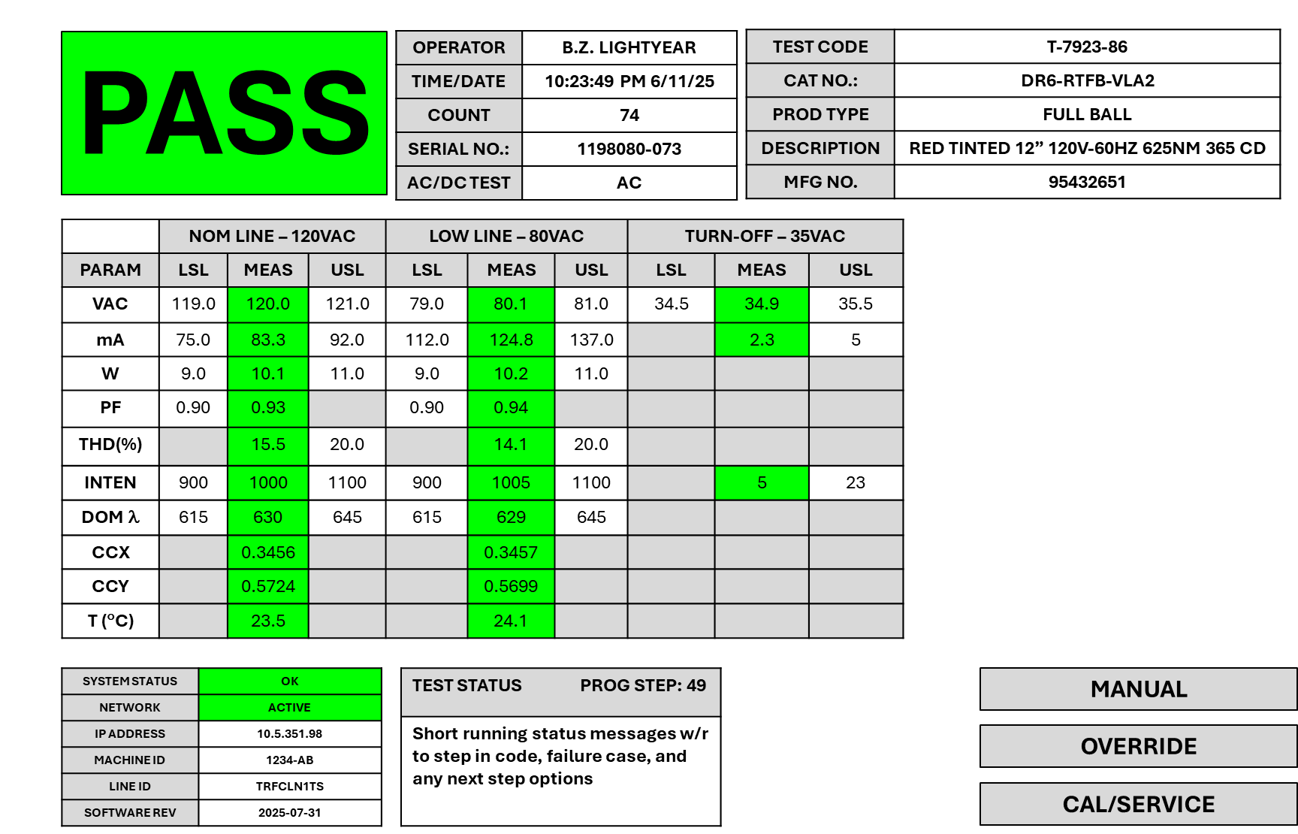

Figure 1 - FULL BALL and ARROW in PASS State connected to Network

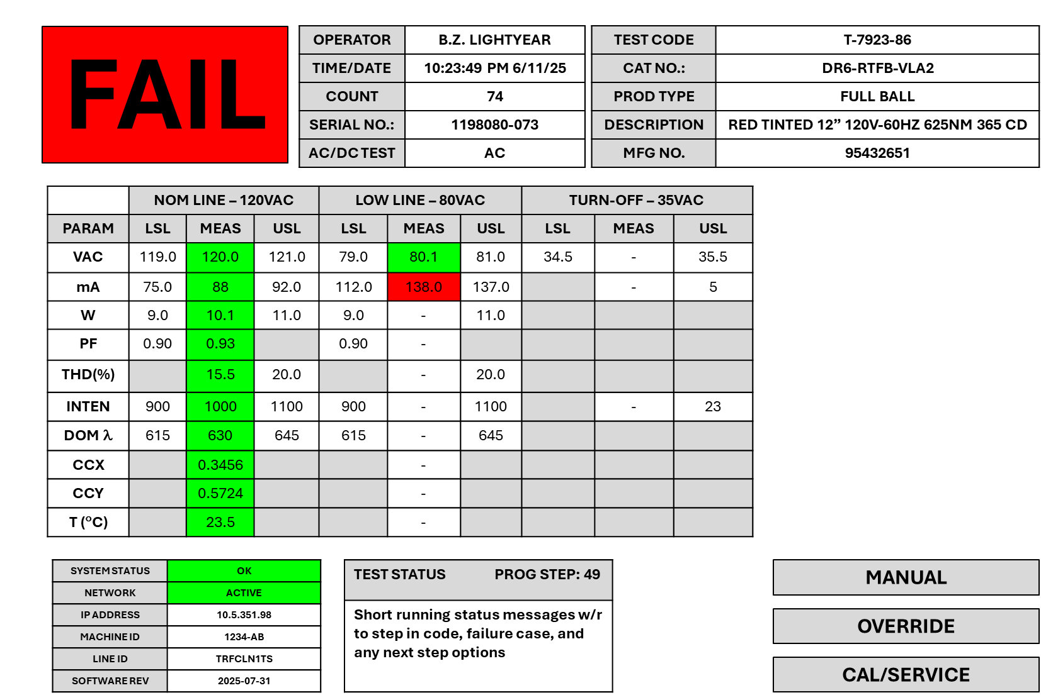

Figure 2 - FULL BALL and ARROW in FAIL state connected to Network

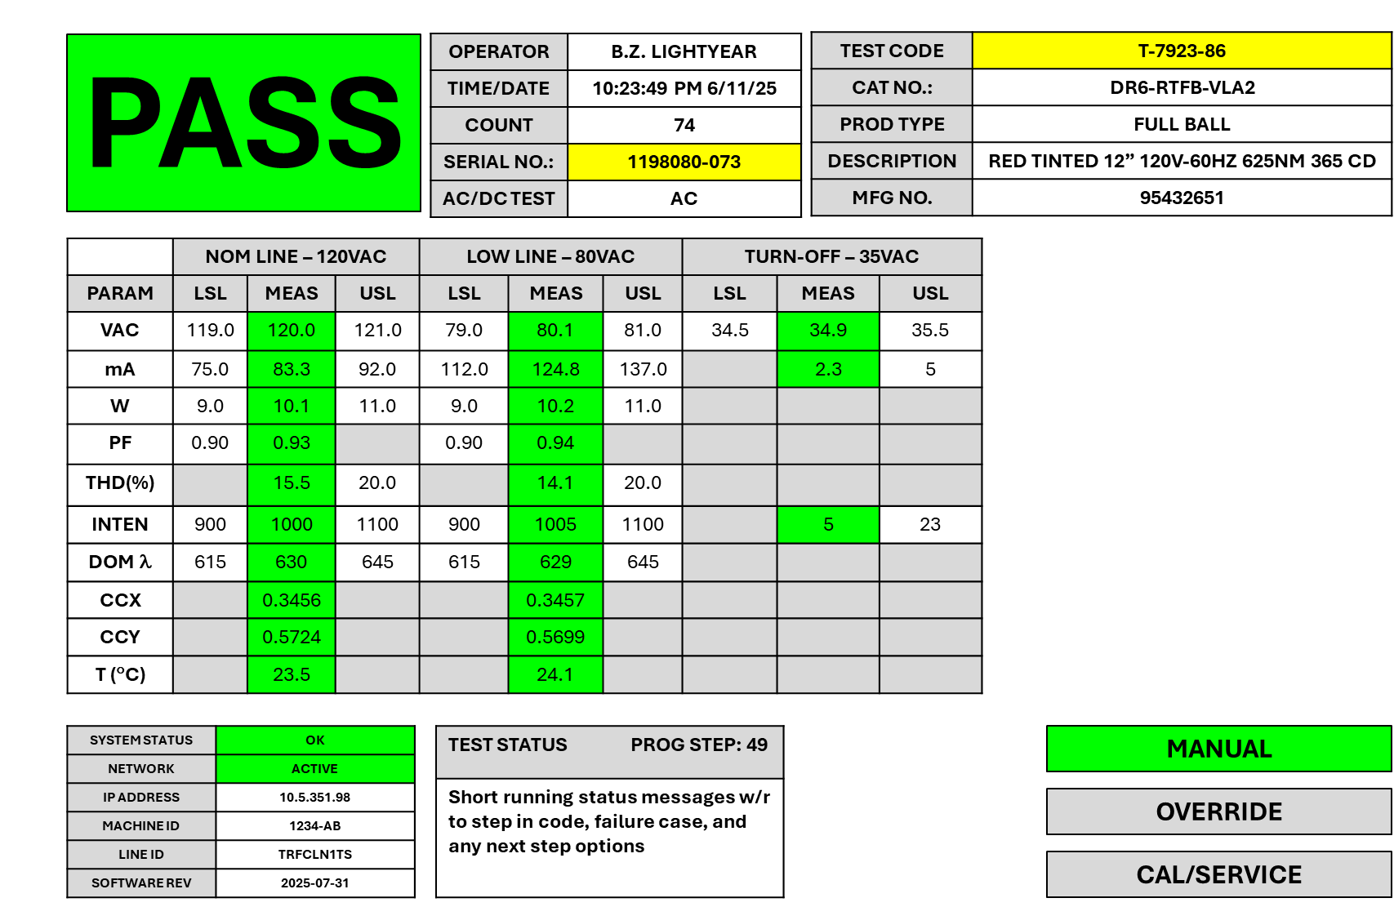

Figure 3 – FULL BALL and ARROW in PASS state in MANUAL mode

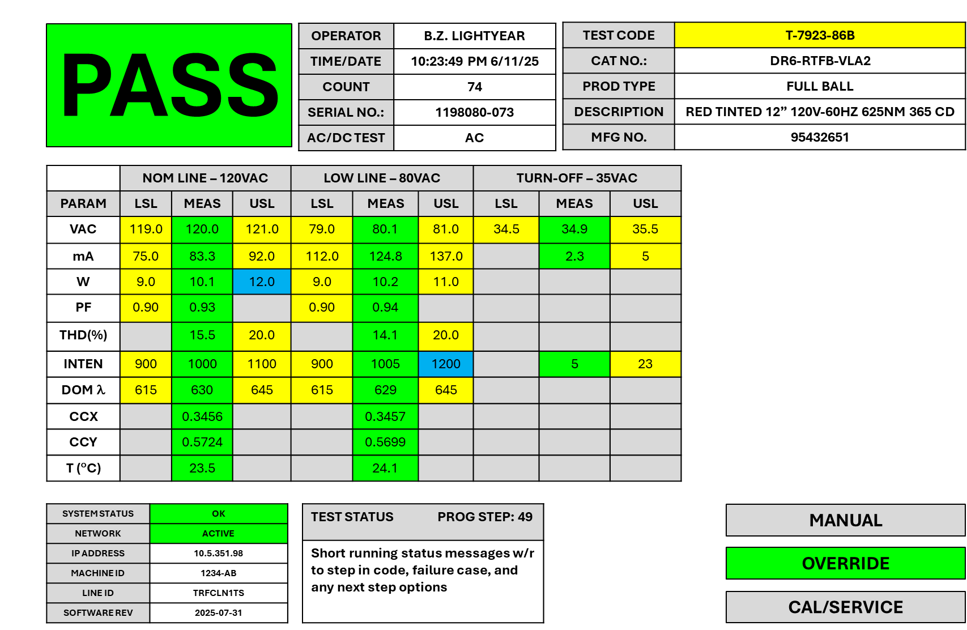

Figure 4 – FULL BALL and ARROW in PASS state in OVERRIDE mode

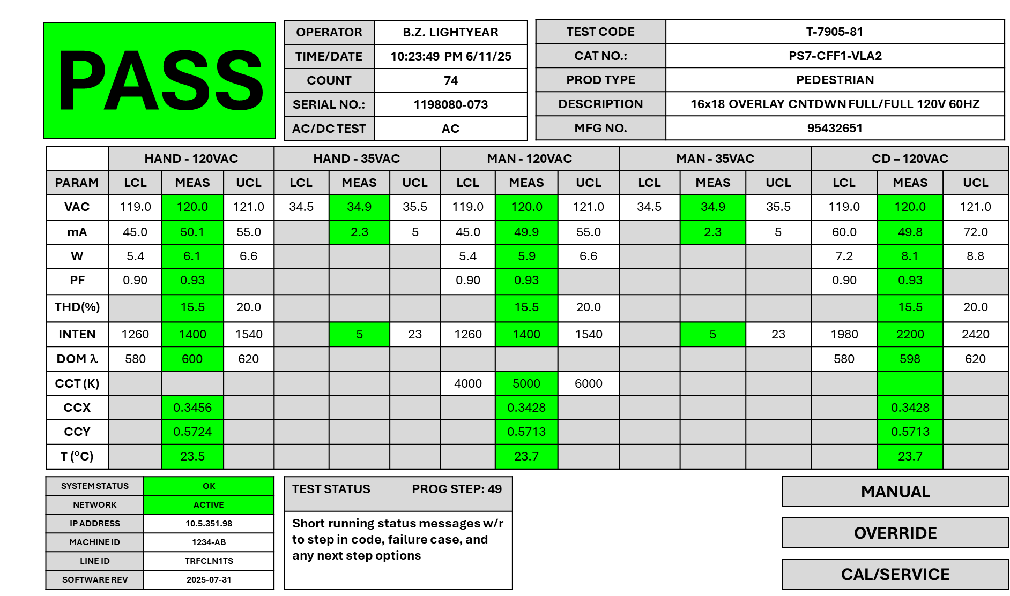

Figure 3 - PEDESTRIAN in PASS state

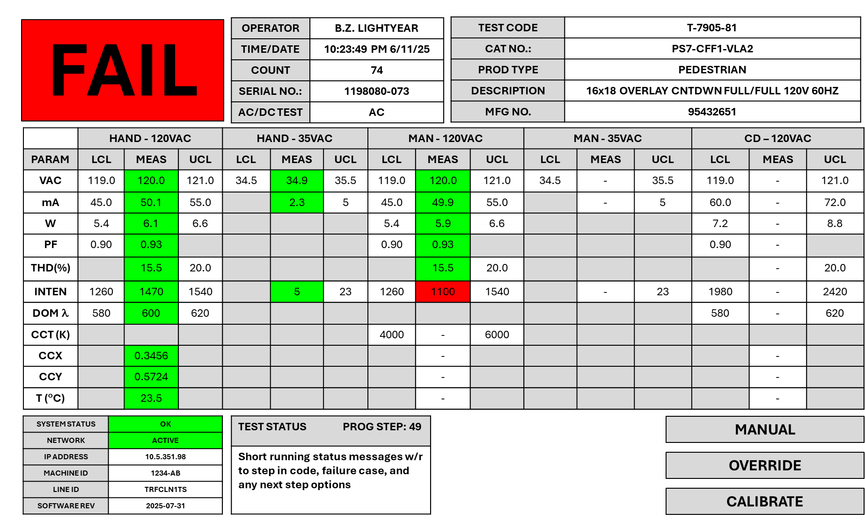

Figure 4 - PEDESTRIAN in FAIL state

b. Calibration and Service

Calibration stability is a key performance need for this test system. The software associated with recording

**13. User Types and Permissions**

The following are the defined user types and permissions for the system:

Test Operator – Allowed to run system in automatic (networked) and manual modes

Production Supervisor – Allowed to run system in automatic (networked) and manual modes. Allowed to authorize and enter OVERRIDE for test limits and permit operator use under OVERRIDE conditions.

Calibration Technician – Allowed to run CALIBRATION process and use any SERVICE routines to check subsystem function, align, or calibrate the system.

Engineering (Mfg or Technology) – All of the above.

**14. Test Process Flow by Product Type**

The following are the basic operating goals of the traffic test station.

a. Takt Time Goal (Load, Test, Unload): 30 seconds

b. Measurement Sequence and Timing

**15. Cyber Security/Documentation Measures**

a. OWASP

b. Commenting Practice in Code

**16. Technical Support Features**

a. Remote Access/Debugging

b. Phone/Email Support

c. Other?

**17. Project Acceptance criteria**

a. Deliverables list

b. PVP Completion

c. Executable and Source Code Delivery

d. Documentation Detail … support future developer understanding of Code funcation

e. Team Signoff